Product Requirements Document

AI-Powered Test Automation (Deterministic, Human-Validated)

Table of Contents
Product Requirements Document 1
AI-Powered Test Automation (Deterministic, Human-Validated) 1
Overview 3
Problem Statement 3
Goals 4
Scope 4
In Scope 4
Out of Scope 4
Primary Target User 4
Functional Requirements 6
Test Project & Test Case Organization 6
Test Project Structure 6
Test Suite Organization 6
Tagging and Classification 7
Traceability at Project Level 7
Versioning at Project Level 7
Execution at Project / Suite Level 8
Ownership and Access 8
Requirement Ingestion and Analysis 8
Test Scenario Generation 9
Test Case Generation 9
Automation Script Generation 10
Script Review and Approval 10
Execution Support 11
Failure Analysis and Reporting 11
Artifact Management and Traceability 11
Non-Functional Requirements 12
Determinism 12
Governance and Human Control 12
Performance 13
Scalability 13
Cost Control 13
Security 13
Maintainability 14
Observability 14
Compliance and Auditability 14

Overview
This product introduces an AI-assisted workflow to generate structured test cases from user stories and generate Playwright automation scripts from approved test cases. The system enforces human validation gates before any artifact is committed to source control or executed in CI/CD.
The primary objective is to reduce manual QA effort while maintaining strict governance, determinism, traceability, and cost control.

Problem Statement
Manual test case authoring and automation script development are the most time-consuming phases in the current QA workflow. Additionally:
- Coverage depends heavily on individual tester experience.
- Regression maintenance effort grows over time.
- Script quality varies.
- Traceability between requirements and automation is inconsistent.
- Introducing AI without control risks nondeterministic behavior and governance issues.
A controlled, deterministic, human-in-the-loop AI workflow is required.

Goals
- Reduce time spent on test case authoring.
- Reduce time spent on Playwright script creation.
- Improve coverage of edge and negative scenarios.
- Maintain full human approval control.
- Ensure traceable and versioned artifacts.
- Keep AI usage predictable and cost-bounded.

Scope

In Scope
- Requirement ingestion (user stories and acceptance criteria)
- AI-generated structured test cases
- Human approval workflow for test cases
- AI-generated Playwright scripts from approved test cases
- Human approval workflow for scripts
- Execution with screenshot capture
- Failure analysis and summary reporting
- Versioned artifact storage (JSON or equivalent structured format)

Out of Scope
- Fully autonomous AI testing
- Continuous automatic regeneration without review
- Replacement of CI/CD tooling
- Cross-framework support beyond Playwright (PoC phase)

Primary Target User
The primary target user is the QA Engineer / Test Engineer responsible for translating user stories into test cases, building and maintaining automation scripts, executing regression suites, and reporting defects.
This user currently spends significant time interpreting requirements, expanding scenarios, writing detailed test steps, implementing Playwright scripts, debugging failures, and maintaining traceability between requirements and tests.

Workflow
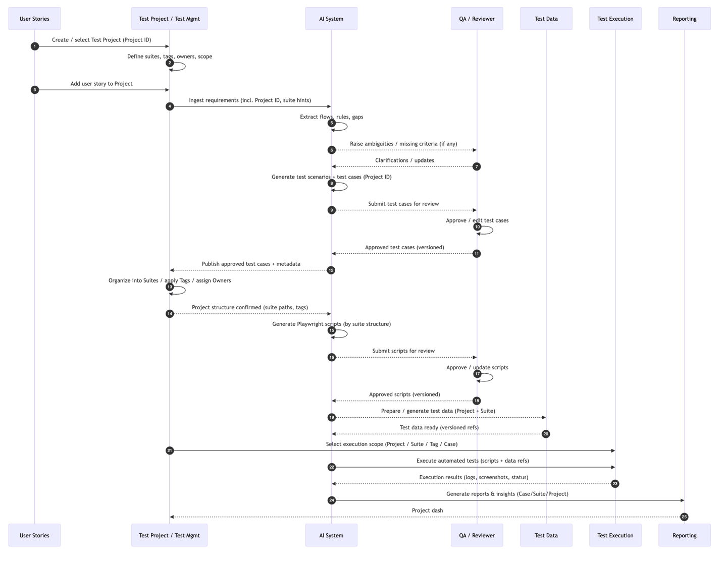

Functional Requirements

Test Project & Test Case Organization

Test Project Structure
The system shall allow creation of a Test Project to group related Requirements, Test Cases, and Automation Scripts.
The system shall allow multiple Test Projects to coexist.
The system shall allow Test Projects to be organized by:
- Product
- Module
- Feature area
- Release
- Environment
The system shall assign a unique Project ID to each Test Project.

Test Suite Organization
The system shall allow grouping of Test Cases into Test Suites within a Test Project.
The system shall support hierarchical folder structures for organizing Test Suites.
The system shall allow a Test Case to belong to multiple Test Suites (without duplication).
The system shall prevent duplicate Test Case IDs across the system.

Tagging and Classification
The system shall allow tagging of Test Cases and Scripts using metadata, including:
- Regression
- Smoke
- Sanity
- Critical
- High Priority
- API / UI
- Security
- Performance
The system shall allow filtering by tag.
The system shall allow bulk tagging operations.

Traceability at Project Level
The system shall display traceability coverage at the Test Project level, including:
- % of Requirements with approved Test Cases
- % of Test Cases automated
- % of automated tests passing
The system shall allow viewing all Test Cases linked to a specific Requirement within a Test Project.
The system shall allow viewing all Requirements covered by a specific Test Suite.

Versioning at Project Level
The system shall allow snapshotting a Test Project at a specific point in time.
The system shall preserve historical versions of Test Projects.
The system shall allow comparison between two project snapshots.

Execution at Project / Suite Level
The system shall allow execution of:
- Entire Test Project
- Specific Test Suite
- Tag-based subset
- Individual Test Case
The system shall generate execution reports grouped by Project and Suite.

Ownership and Access
The system shall allow assignment of Project-level owners.
The system shall support role-based access at the Test Project level.
The system shall restrict modification of Test Suites to authorized roles.

Requirement Ingestion and Analysis
The system shall accept structured user stories containing title, description, and acceptance criteria.
The system shall support semi-structured requirement inputs, including formatted documents and copied text.
The system shall extract functional flows, preconditions, postconditions, and embedded business rules from requirement content.
The system shall identify dependencies, authentication requirements, validation rules, and system constraints described in the requirement.
The system shall detect ambiguous language, incomplete flows, missing acceptance criteria, and logical conflicts.
The system shall present detected ambiguities or gaps to the user for clarification prior to generating test cases.
The system shall assign and maintain a unique Requirement ID for each ingested story.
The system shall establish traceability between the Requirement ID and all downstream artifacts.

Test Scenario Generation
The system shall generate comprehensive test scenarios derived from both explicit and inferred requirement logic.
The system shall include happy path, negative, edge case, boundary value, validation, and authorization scenarios where applicable.
The system shall infer additional logical scenarios not explicitly written in the acceptance criteria.
Each generated scenario shall reference the originating Requirement ID.
The system shall prevent duplicate scenario generation for the same requirement.

Test Case Generation
The system shall generate structured test cases from approved scenarios.
Each test case shall include a unique Test Case ID.
Each test case shall include title, linked Requirement ID, preconditions, step-by-step actions, expected results, priority classification, and test type.
Test cases shall follow a standardized format aligned with existing QA templates.
The system shall allow users to edit generated test cases prior to approval.
The system shall maintain version history of test cases, including AI-generated content and human-edited revisions.
The system shall record approval status, reviewer identity, and timestamps.
The system shall prohibit automation script generation unless the test case is formally approved.

Automation Script Generation
The system shall generate Playwright automation scripts based solely on approved test cases.
Generated scripts shall follow predefined framework conventions, naming standards, and directory structures.
The system shall support configurable language selection consistent with the framework (e.g., TypeScript or Python).
The system shall generate reusable components or page objects where patterns are detected.
Generated scripts shall include appropriate assertions aligned with expected results.
The system shall include error handling and appropriate wait mechanisms in generated scripts.
The system shall avoid hard-coded sensitive data and credentials.
The system shall validate generated scripts against structural rules before presenting them for review.

Script Review and Approval
The system shall require manual review and approval of generated scripts before they can be committed to source control.
The system shall provide side-by-side comparison between generated and edited script versions.
The system shall maintain script version history, including AI-generated and human-modified revisions.
The system shall record reviewer identity, approval status, and timestamp for audit purposes.
The system shall allow regeneration of scripts when requirements or test cases change.

Execution Support
The system shall support integration with existing CI/CD pipelines.
The system shall support screenshot capture during automated test execution.
The system shall collect and store execution logs and artifacts.
The system shall allow selective re-execution of specific test cases.
The system shall link execution results back to the corresponding Test Case ID and Requirement ID.

Failure Analysis and Reporting
The system shall classify test failures into defined categories such as assertion failure, locator issue, authentication issue, or environment error.
The system shall identify potential flaky tests based on historical execution patterns.
The system shall generate human-readable summaries of execution results.
The system shall provide trend analysis and highlight high-risk areas based on repeated failures.
The system shall maintain traceability between failure reports and corresponding test cases and requirements.

Artifact Management and Traceability
The system shall store all AI-generated artifacts in a structured, versioned format.
Each artifact shall include a unique identifier, parent Requirement ID, version number, generation timestamp, and reference to model or prompt version.
The system shall allow regeneration of artifacts when requirements change while preserving historical versions.
The system shall ensure complete auditability across requirement ingestion, test case generation, script generation, execution, and reporting.

Non-Functional Requirements

Determinism
Given identical inputs and the same model/prompt version, outputs must be reproducible.
Prompt templates must be version-controlled.
Model version must be logged for every generation event.
Temperature and randomness settings must be controlled to minimize variability.

Governance and Human Control
No artifact may be automatically merged or executed without human approval.
All actions must be auditable.
Approval workflows must be enforceable and non-bypassable.
The system must log:
- Who approved
- When approved
- What changed between versions

Performance
Test case generation should complete within an acceptable time window (target: under 30 seconds per standard user story).
Script generation should complete within an acceptable time window (target: under 45 seconds per standard story).
The system must handle concurrent generation requests for multiple stories (PoC: small batch support).

Scalability
Architecture must support scaling beyond single-story PoC.
Artifact storage must support growing historical datasets.
Failure analysis should support increasing execution volume over time.

Cost Control
AI invocation frequency must be limited.
Generation should occur once per approved story unless regeneration is explicitly triggered.
Long-running token-heavy analysis must be avoided in CI.
The system must support tracking token usage per story.

Security
The system must not expose credentials in generated scripts.
Sensitive data must be masked in logs and stored artifacts.
Access to approval workflows must be role-based.
Only authorized users may trigger regeneration or approvals.

Maintainability
Prompt templates must be modular and updatable without breaking stored artifacts.
Artifact schema must support backward compatibility.
Framework conventions must be centrally configurable.

Observability
The system must log:
- Generation duration
- Token usage
- Approval time
- Execution duration
- Failure categories
Dashboards should summarize performance and efficiency metrics.

Compliance and Auditability
All AI-generated and human-edited content must be traceable.
Version history must be immutable.
Audit logs must be exportable.

Mermaid code:
sequenceDiagram
autonumber
participant US as User Stories
participant PM as Test Project / Test Mgmt
participant AI as AI System
participant QA as QA / Reviewer
participant TD as Test Data
participant TE as Test Execution
participant RP as Reporting

%% --- Project setup / organization layer ---
US->>PM: Create / select Test Project (Project ID)
PM->>PM: Define suites, tags, owners, scope

%% --- Requirement ingestion (project-aware) ---
US->>PM: Add user story to Project
PM->>AI: Ingest requirements (incl. Project ID, suite hints)
AI->>AI: Extract flows, rules, gaps
AI-->>QA: Raise ambiguities / missing criteria (if any)
QA-->>AI: Clarifications / updates

%% --- Test case generation & review ---
AI->>AI: Generate test scenarios + test cases (Project ID)
AI-->>QA: Submit test cases for review
QA->>QA: Approve / edit test cases
QA-->>AI: Approved test cases (versioned)

%% --- NEW: Organize test cases into suites/tags ---
AI-->>PM: Publish approved test cases + metadata
PM->>PM: Organize into Suites / apply Tags / assign Owners
PM-->>AI: Project structure confirmed (suite paths, tags)

%% --- Script generation & review ---
AI->>AI: Generate Playwright scripts (by suite structure)
AI-->>QA: Submit scripts for review
QA->>QA: Approve / update scripts
QA-->>AI: Approved scripts (versioned)

%% --- Test data preparation (project-scoped) ---
AI-->>TD: Prepare / generate test data (Project + Suite)
TD-->>AI: Test data ready (versioned refs)

%% --- Execution (project/suite/tag based) ---
PM->>TE: Select execution scope (Project / Suite / Tag / Case)
AI->>TE: Execute automated tests (scripts + data refs)
TE-->>AI: Execution results (logs, screenshots, status)

%% --- Reporting (project-level rollups) ---
AI->>RP: Generate reports & insights (Case/Suite/Project)
RP-->>PM: Project dash

